EXPERIMENT NO.3
1.Reverse a String

Index.html
<!DOCTYPE html>
<html>
<head>
<title>Reverse String Recursively</title>
</head>
<body>
<h2>Reverse a String Using Recursion</h2>
<label>Enter a string:</label>
<input type="text" id="inputString"><br><br>
<button onclick="reverseString()">Reverse</button>
<h3 id="result"></h3>
<script src="script.js"></script>
</body>
</html>

Script.js function recursiveReverse(str) {
if (str === "") { return "";
}
return recursiveReverse(str.substring(1)) + str.charAt(0);
}function reverseString() {
let str = document.getElementById("inputString").value; let length = str.length; console.log("Length of string:", length); // Optional: for debugging let reversedStr = recursiveReverse(str); document.getElementById("result").innerText = "Reversed String: " + reversedStr;
}

Output

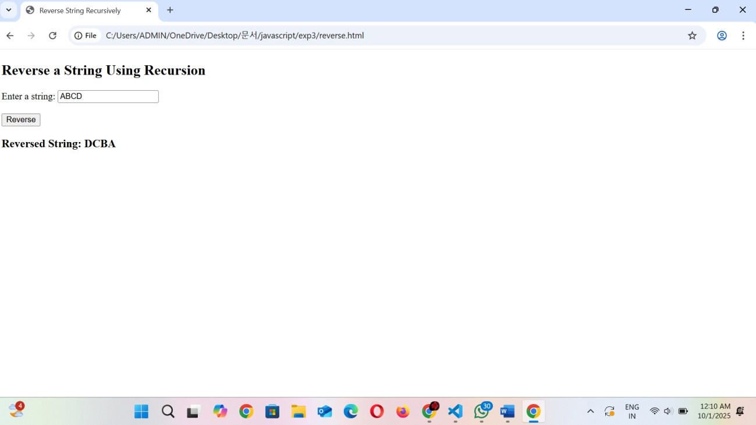

2.Replace Character of a string

Index.html
<!DOCTYPE html>
<html>
<head>
<title>Replace Substring in String</title>
</head>
<body>
<h2>Replace a Substring Using JavaScript</h2>
<label>Enter the original string:</label>
<input type="text" id="inputString"><br><br>
<label>Enter the text to replace:</label>
<input type="text" id="matchText"><br><br>
<label>Enter the replacement text:</label>
<input type="text" id="patternText"><br><br>
<button onclick="replaceText()">Replace</button>
<h3 id="result"></h3>
<script src="script.js"></script>
</body>
</html>

Script.js function replaceText() let str = document.getElementById("inputString").value; let match = document.getElementById("matchText").value; let pattern = document.getElementById("patternText").value; let newStr = str.replace(match, pattern); document.getElementById("result").innerText = "New String: " + newStr;
}

Output

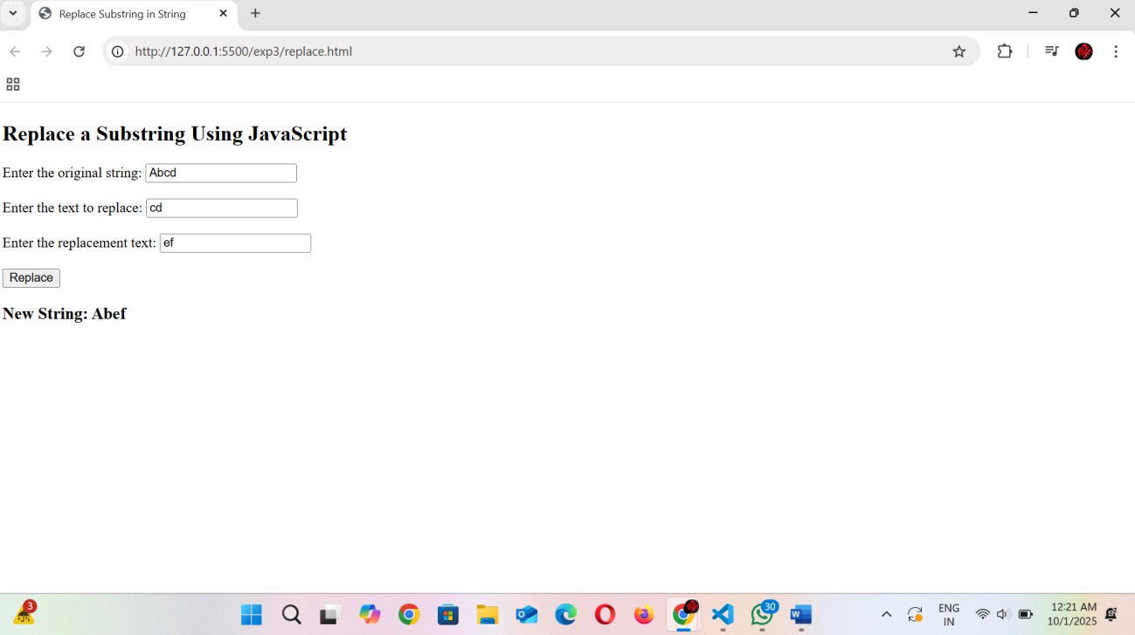
3.String is palindrome

Index.html
<!DOCTYPE html>
<html>
<head>
<title>Palindrome Check</title>
</head>
<body>
<h2>Check Palindrome</h2>
<label>Enter a string:</label>
<input type="text" id="inputString"><br><br>
<button onclick="checkPalindrome()">Check</button>
<h3 id="result"></h3>
<script src="script.js"></script>
</body>
</html>

script.js function checkPalindrome() { let str = document.getElementById("inputString").value; let reversedStr = str.split("").reverse().join(""); let isPalindrome = (str === reversedStr); if (isPalindrome) { document.getElementById("result").innerText = `"${str}" is a Palindrome`;
} else {
document.getElementById("result").innerText = `"${str}" is NOT a Palindrome`;
}
}

Output

